Angular Dev Tools

<https://v17.angular.io/guide/devtools>

<https://angular.dev/tools/devtools>

Install Angular DevTools from the [Chrome Web Store](https://chrome.google.com/webstore/detail/angular-developer-tools/ienfalfjdbdpebioblfackkekamfmbnh) or from [Firefox Addons](https://addons.mozilla.org/firefox/addon/angular-devtools/).

After Installing the extension, click on the puzzle piece icon:

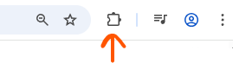

There should be an extension called: Angular Dev Tools.

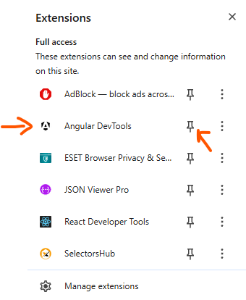

Click on the pin icon to have it pinned:

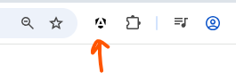

By default, the icon will be black, if we click on the icon, the extension will tell us that it hasn’t detected the Angular app.

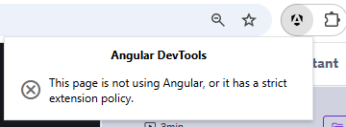

Let’s switch over to our app.

Almost immediately, the icon will turn red.

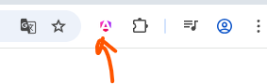

If we click on it, Angular has been detected by the extension, however, where are the tools?

The developer tools must be open for viewing the new tool. There should be a new panel called Angular.

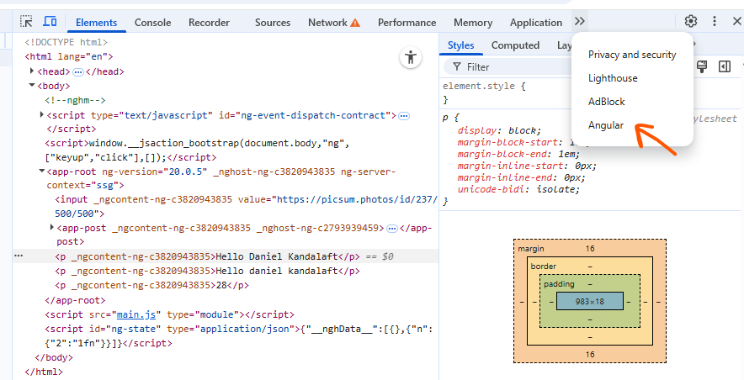

On this panel, we will find a hierarchy of components for our application.

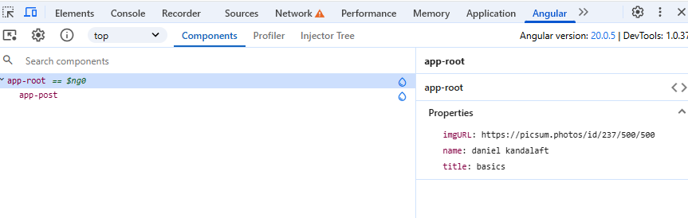

We can select the components to view its data, for example, if we click on the post component, we can check out the properties inside the components:

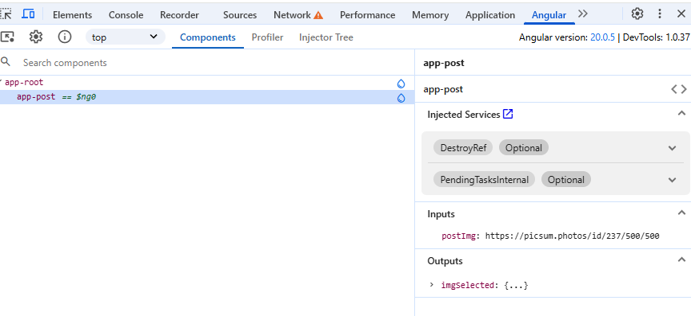

Not only will the tool show us the components properties, but it’ll also categorize the properties. It makes it easier to sort through our data. The properties are not read only. We can freely modify these properties. Any changes we make to the properties will be reflected in our app.

The main reason I’m showing the Angular dev tools, is to show how **pipes** affect our properties.

Switch over to the app component.

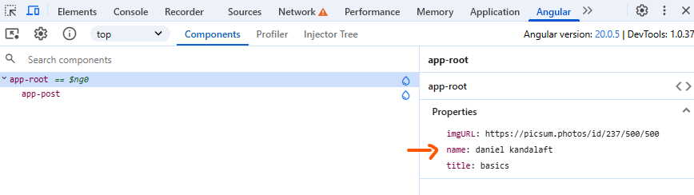

The value for the main property has not changed, it remains lowercase, even though we’ve applied a pipe to this property in our template. The pipe did not change the value in the class.

The developer tools are a great way of verifying this behaviour. Pipes do not change their properties. They change the output in the template. We’ll be using the Dev Tools from time to time to help us debug our application.